Bsp sql delete mit join

Es müssen mehrere records von 2 tabellen gelöscht werden. Es müss ein LEFT JOIN gemacht werden, weil auf der 2. Tabelle die scheduled_id teilweise null ist:

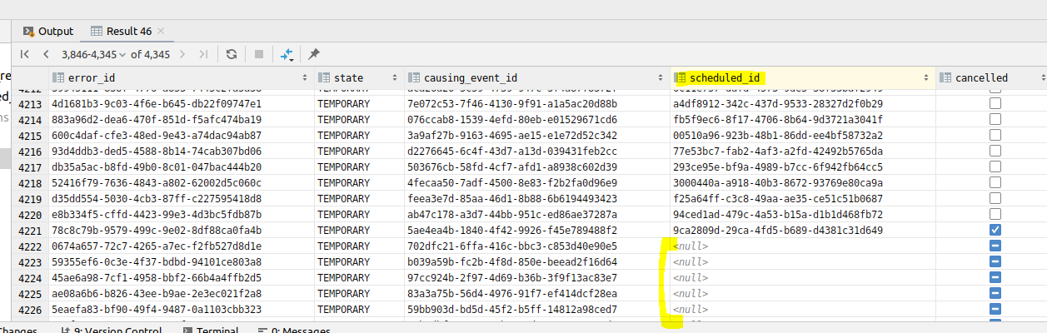

Select query:

select public.error.id as error_id, public.error.state, public.error.causing_event_id, public.scheduled_resend.id as scheduled_id, public.scheduled_resend.cancelled

FROM public.error

LEFT JOIN public.scheduled_resend ON public.error.id=public.scheduled_resend.error_id

WHERE

public.error.error_event_data_message like '%Could not create strategy based on given inspection object%'

OR public.error.error_event_data_message like '%Neither a inspection case reference nor risico rule reference declared%';

Delete query: das ist leider unterschiedlich von mySQl zu PostgreSQL

/////////////////following is only for mySql...use other syntax for PostgreSQL

select public.error.id as error_id, public.error.state, public.error.causing_event_id, public.scheduled_resend.id as scheduled_id, public.scheduled_resend.cancelled

FROM public.error

LEFT JOIN public.scheduled_resend ON public.error.id=public.scheduled_resend.error_id

WHERE

public.error.error_event_data_message like '%Could not create strategy based on given inspection object%'

OR public.error.error_event_data_message like '%Neither a inspection case reference nor risico rule reference declared%';

-------------------------

DELETE public.error, public.scheduled_resend

FROM public.error

LEFT JOIN public.scheduled_resend ON public.error.id=public.scheduled_resend.error_id

WHERE

public.error.error_event_data_message like '%Could not create strategy based on given inspection object%'

OR public.error.error_event_data_message like '%Neither a inspection case reference nor risico rule reference declared%';

////////////////PostgreSQL syntax (mySQL syntax geht hier nicht)

bsp:

DELETE FROM table_name1

USING table_expression

WHERE condition

RETURNING returning_columns;

-> konkret

DELETE FROM t1

USING t2

WHERE t1.id = t2.id

oder auch einfach!!!!!!!!!!!!!!!!!!!!!! mit 2 queries für jede tbl

DELETE FROM t2 WHERE t2.id IN (SELECT t1.id FROM t1 WHERE condition); ---> in diesem fall kein join notwendig

DELET FROM t1 WHERE condition;

----------mySQL variante umgeschrieben auf postgresql

_______1. query___________

DELETE FROM scheduled_resend WHERE public.scheduled_resend.error_id in (

select public.error.id

FROM public.error

WHERE

public.error.error_event_data_message like '%Could not create strategy based on given inspection object%'

OR public.error.error_event_data_message like '%Neither a inspection case reference nor risico rule reference declared%');

_______2. query___________ -> muss 2. query sein, weil es in tbl scheduled_resend die error_id ein fk_constraint ist

DELETE FROM public.error

WHERE

public.error.error_event_data_message like '%Could not create strategy based on given inspection object%'

OR public.error.error_event_data_message like '%Neither a inspection case reference nor risico rule reference declared%';